**Downloading the required software’s**

* First, we download the VirtualBox to run the VM.
* The Seed Ubuntu to Ubuntu on VM.

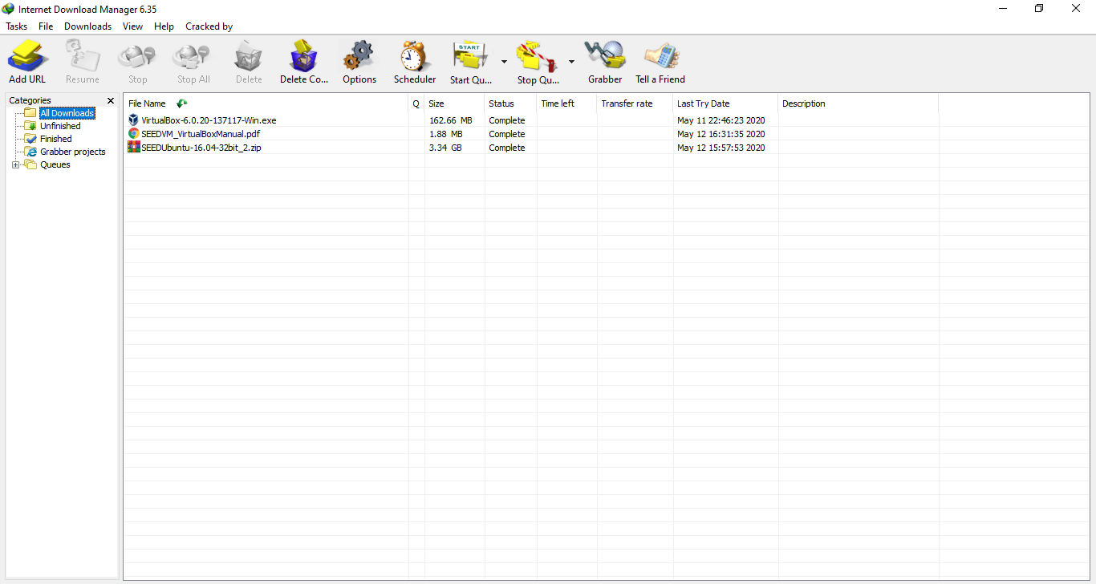

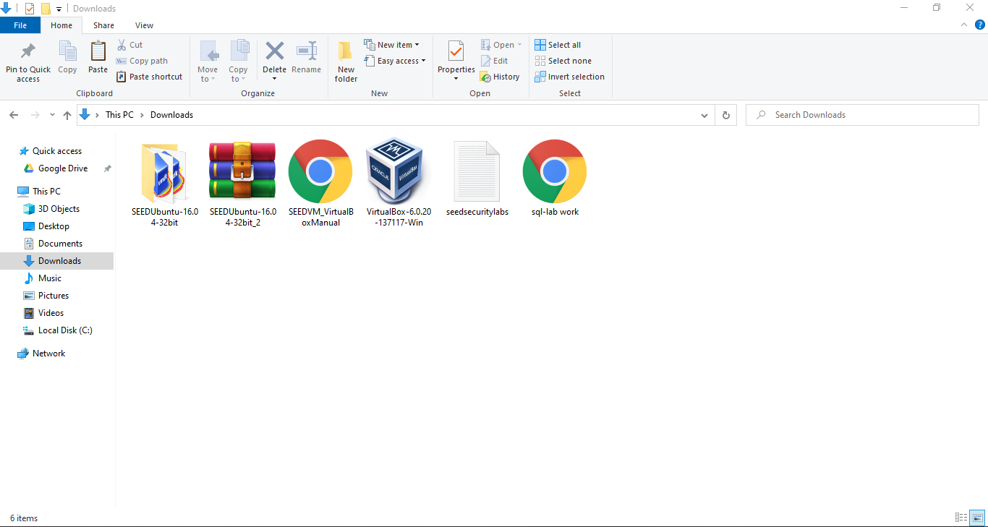

* Extract the Seed Ubuntu files.

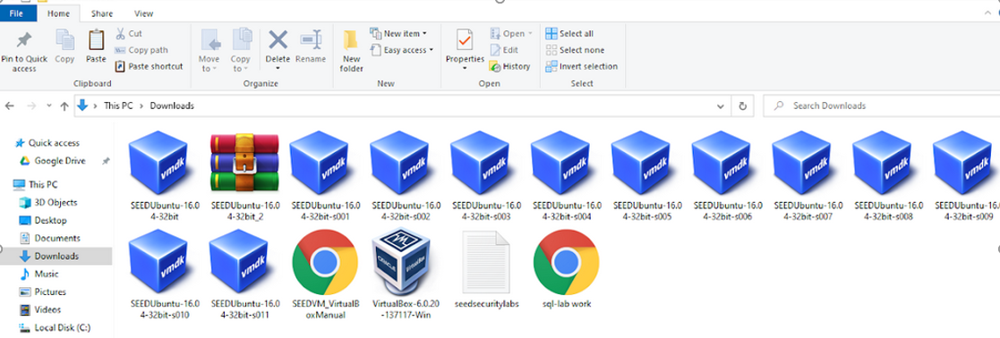

**Installing VirtualBox to run the SEED Ubuntu VM**

Introduce the free VirtualBox programming first.

1. **Creating a New VM in VirtualBox**

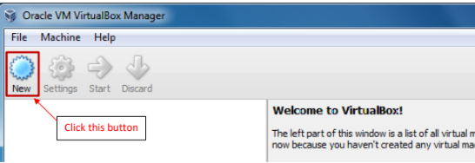

1. **Select OS type and Version**

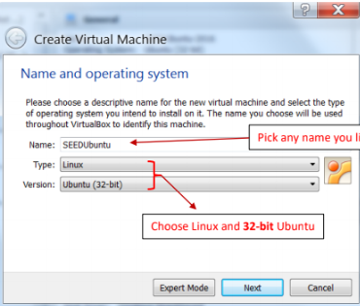

1. **Setting the memory size**

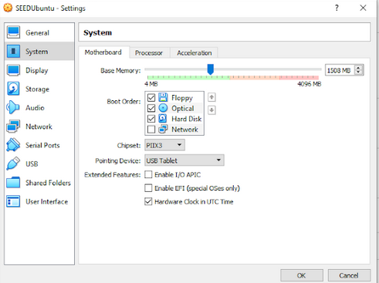

1. **Select the Pre-built VM File**

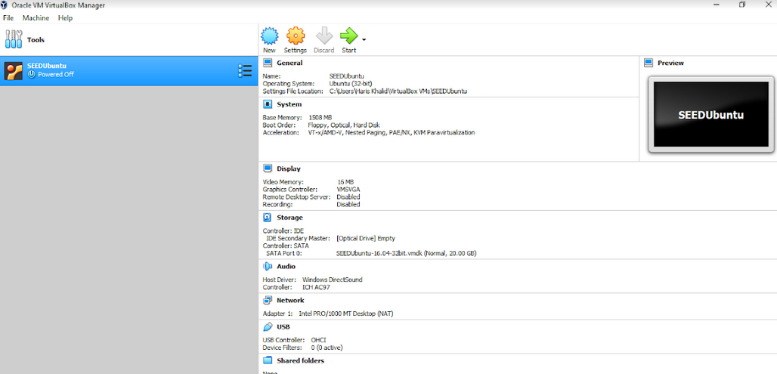

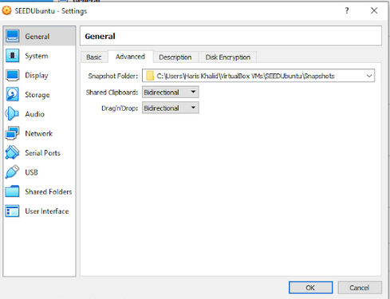

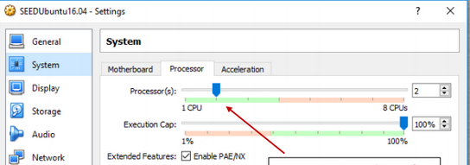

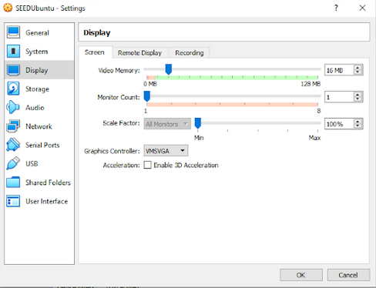

1. **Start the VM**

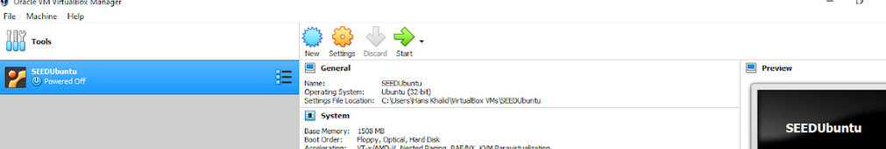

1. **It will take some time to run the ubuntu on VM**

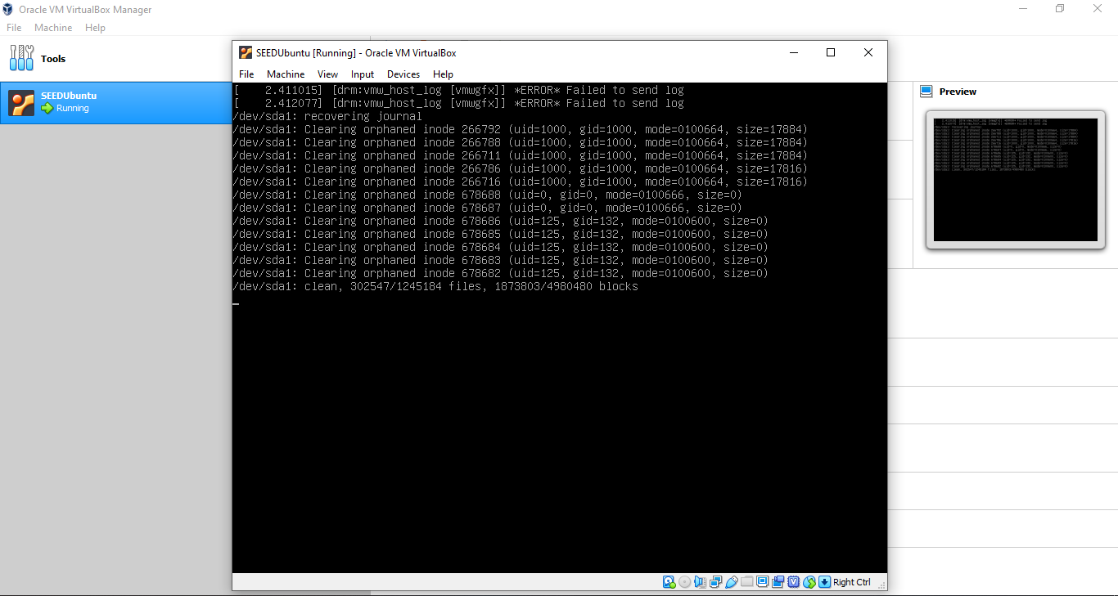

1. **Done.**

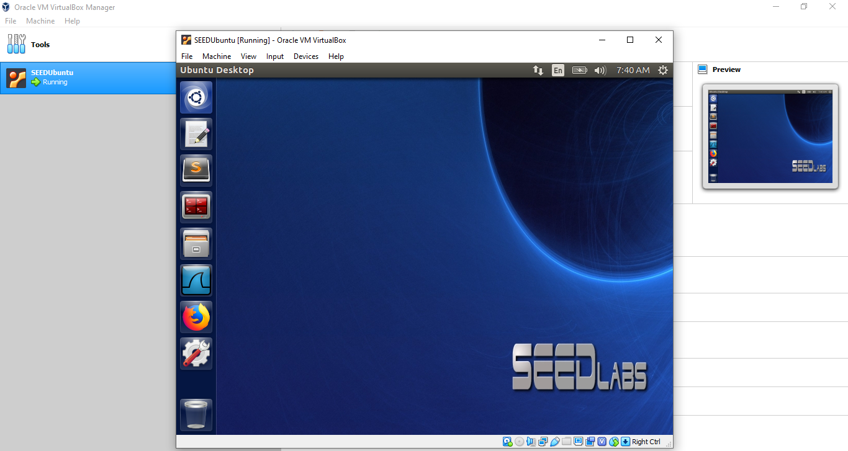

**SQL Injection Attack Lab**

A SQL injection attack inserting a portion of a sequel query into the horrible grey run by the program the scrubs of query and allow the attacker to access the database.

Our first task is to print all profile information and put employee plus, for this we will log into my sequel. For this you will need to open the terminal and start with the below instructions and commands:

**Task 1: Get Familiar with SQL Statements:**

**$ MySQL -u root –pseedubuntu**

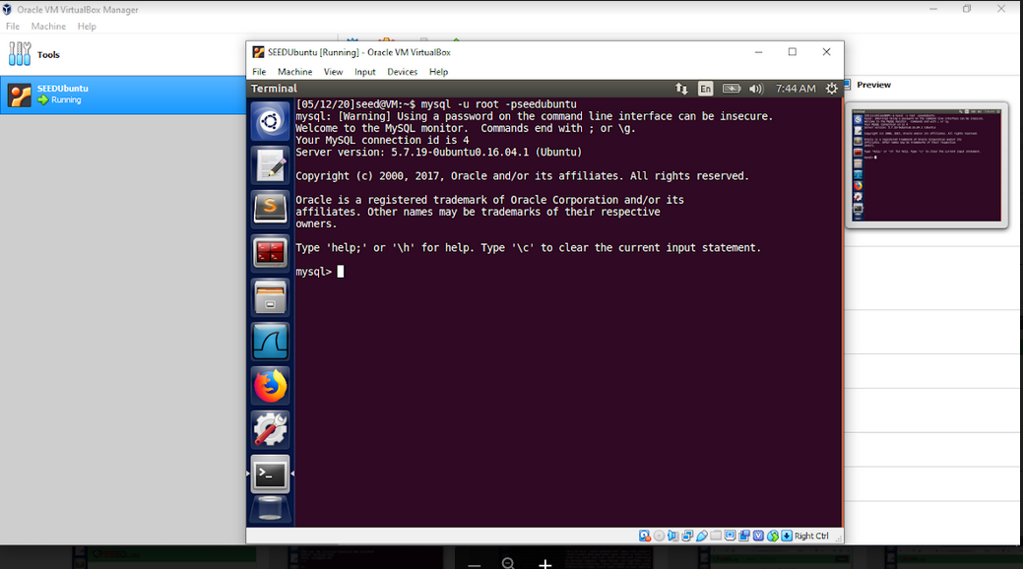

Then use the database Users and for the tables type show tables:

**mysql> use Users;**

**mysql> show tables;**

We go ahead and show the tables within that database as we can see here there’s only one table with the user's database which is credential. We will go ahead and select everything from the credential whereas the name is equal to Alice. Thus our first task is completed.

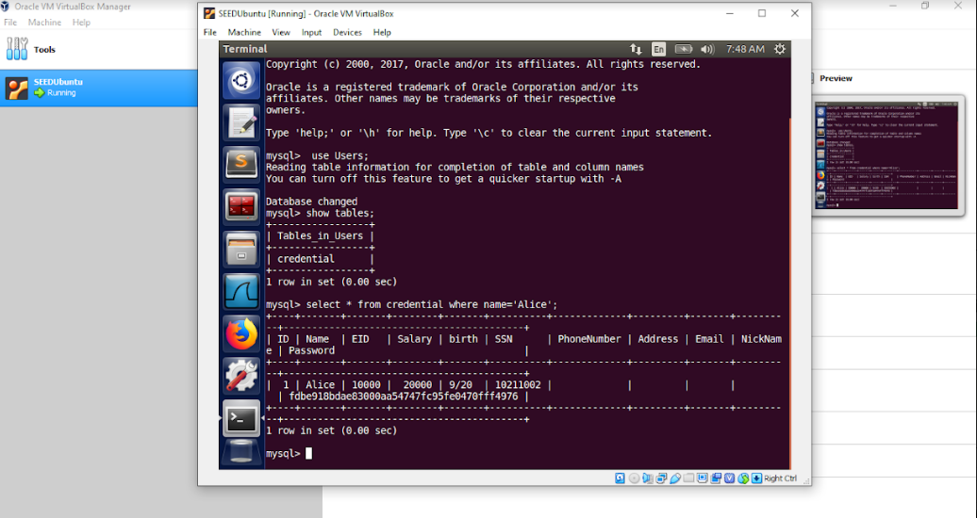

**Task 2: SQL Injection Attack on SELECT Statement:**

SQL injection is a technique through which attackers can execute their malicious SQL statements commonly referred to as the malicious payload. Attackers can steal information from the victim database through the malicious SQL statements; even worse, they may be able to make changes to the database.

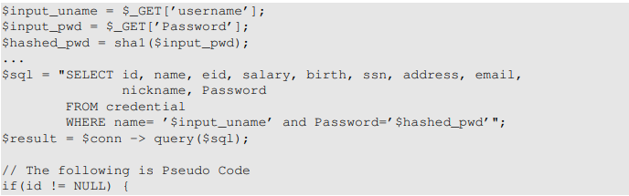

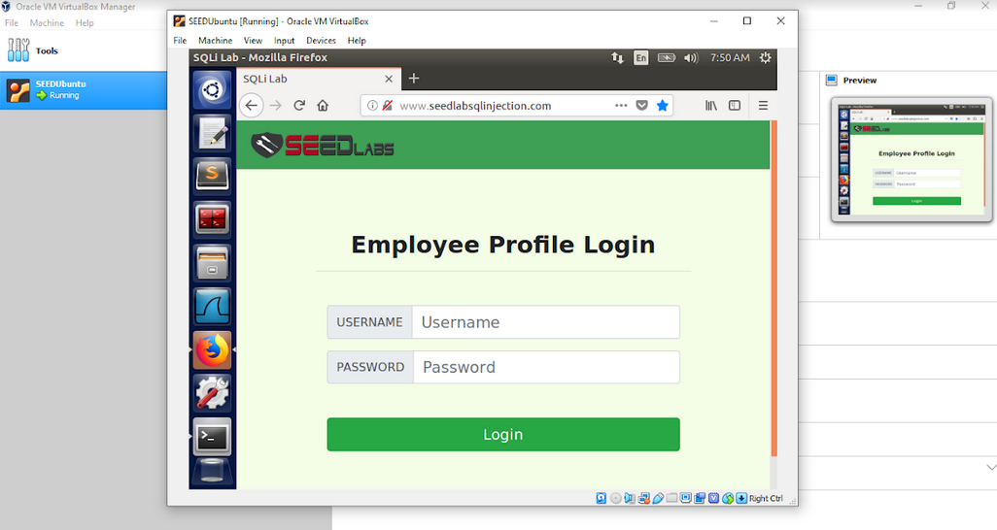

**Task 2.1: SQL Injection Attack from the webpage:**

So, we go ahead and manipulate the vulnerable sequel query that's being formed below. We will use the login page from www.SEEDLabSQLInjection.com for this task. It asks users to provide a username and a password, but we write the **admin’ #** to login to the admin’s account.

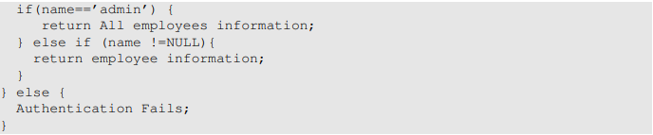

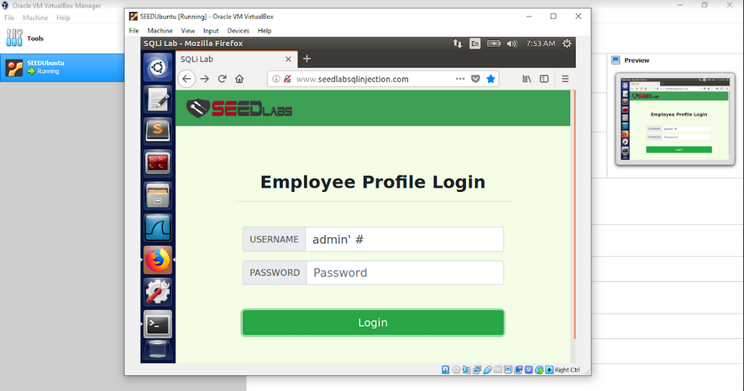

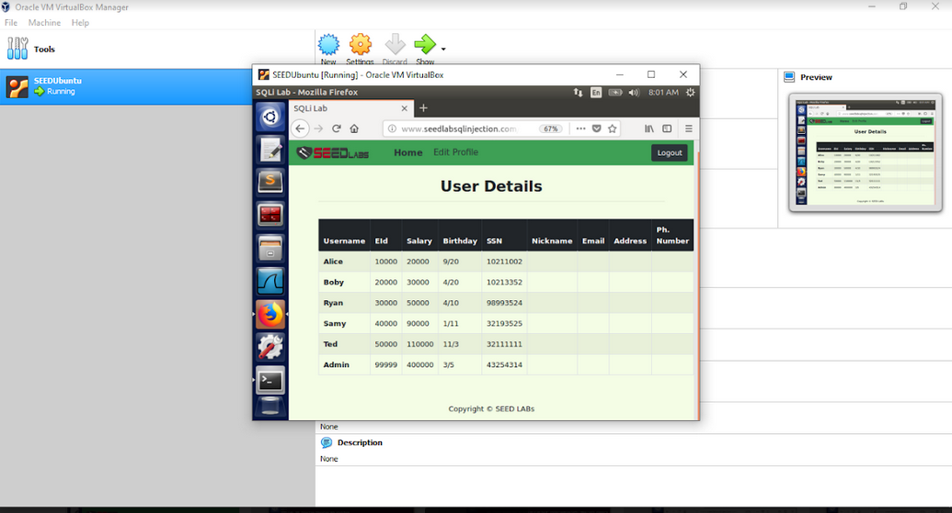

**Task 2.2: SQL Injection Attack from the command line:**

$ curl ’www.SeedLabSQLInjection.com/unsafe_home.php?username=admin%27%20%23’

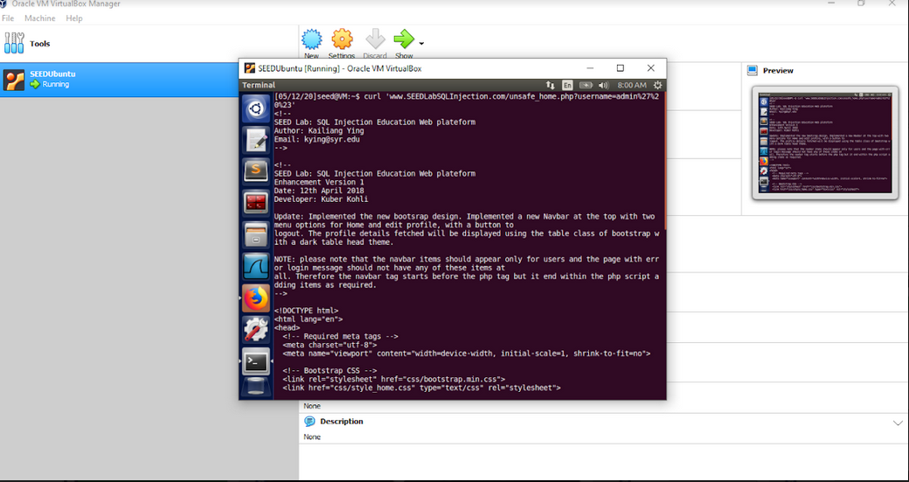

We will get all the information about the admin’s account.

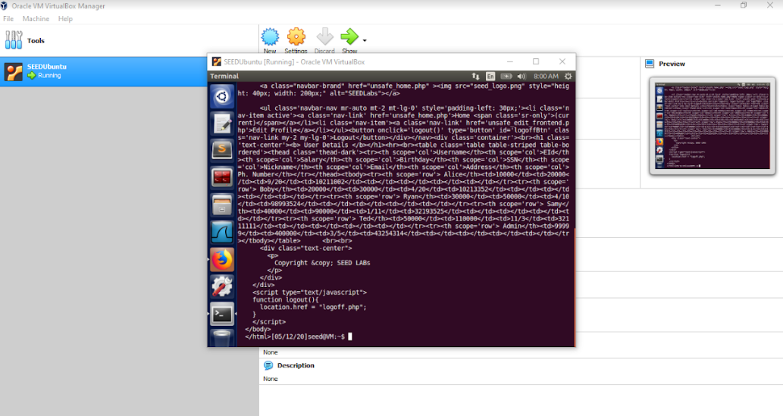

**Task 2.3: Append a new SQL statement:**

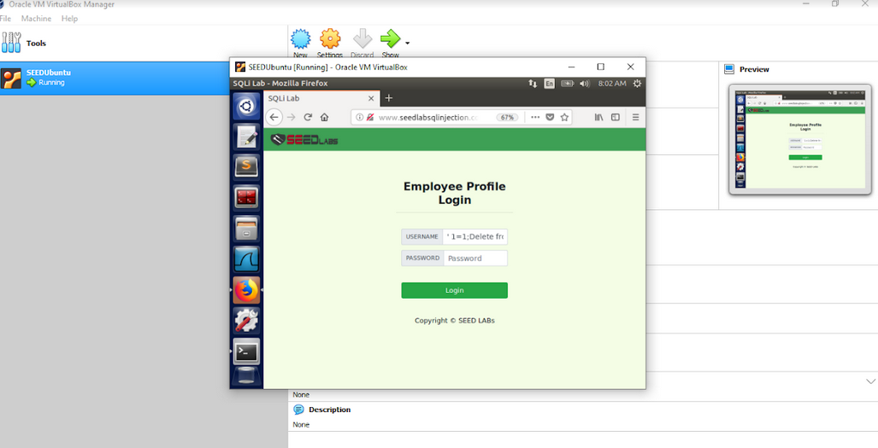

we can see that it was rejected this is due to the C labs preventing us from being upended with the website so this is expecting to fail however we would append two queries together by using the semicolon and starting it from scratch.

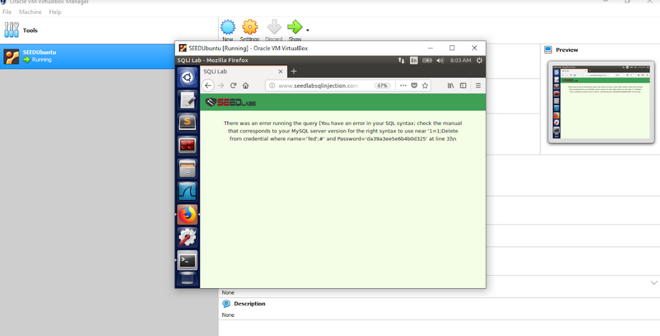

**Task 3: SQL Injection Attack on UPDATE Statement:**

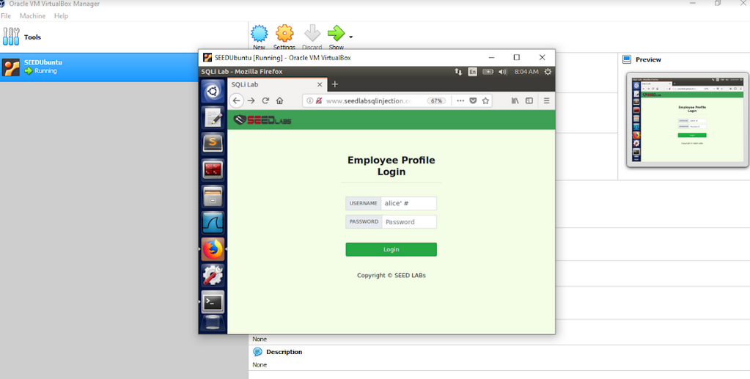

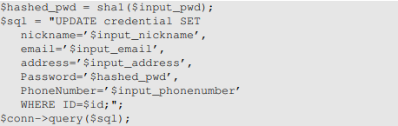

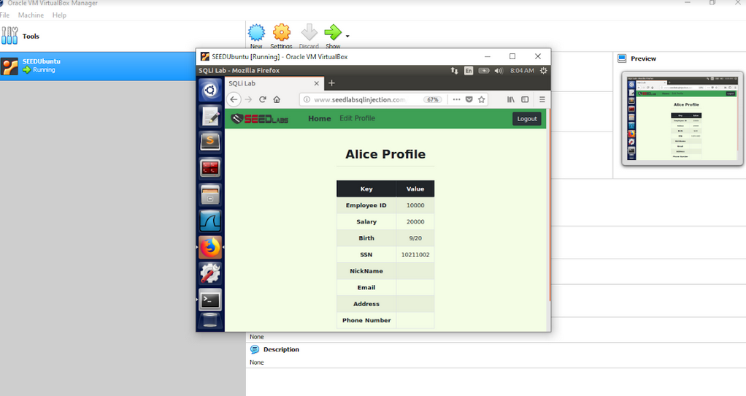

**Task 3.1: Modify your salary:**

As we can see that Alice's salary is 20000 but we will modify it to 500000.



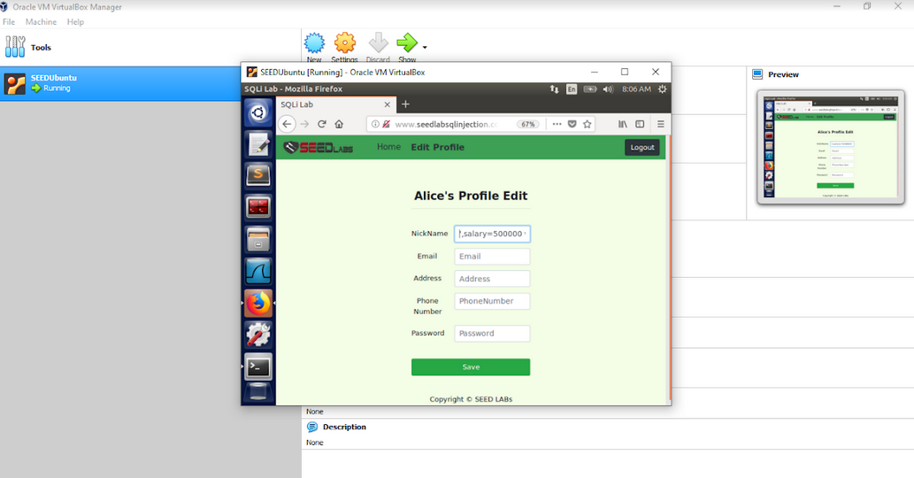

Alice's salary is modified to 500000.

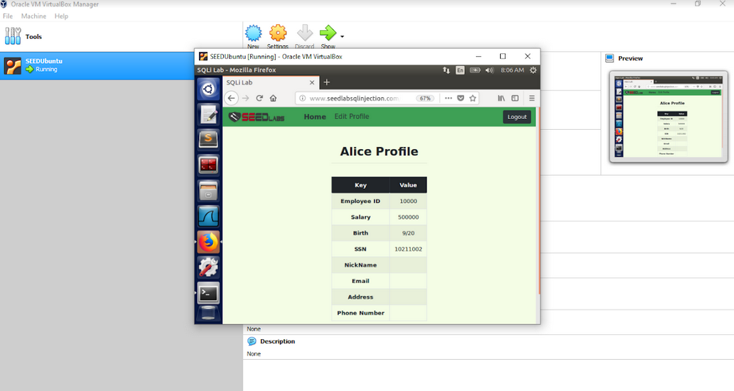

**Task 3.2: Modify other people’s salaries.**

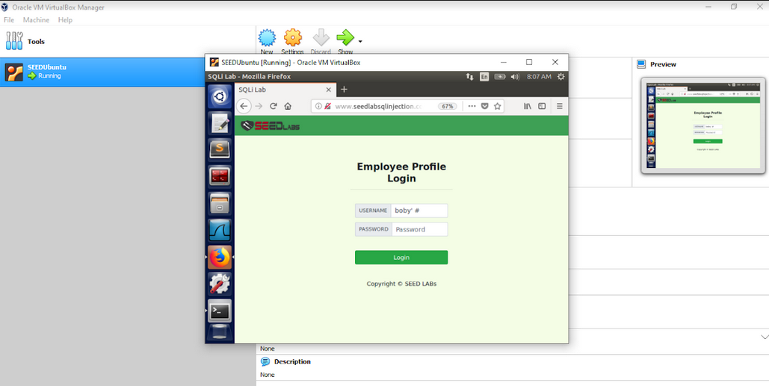

As we can see that the Boby Salary is 30000 now modify it.

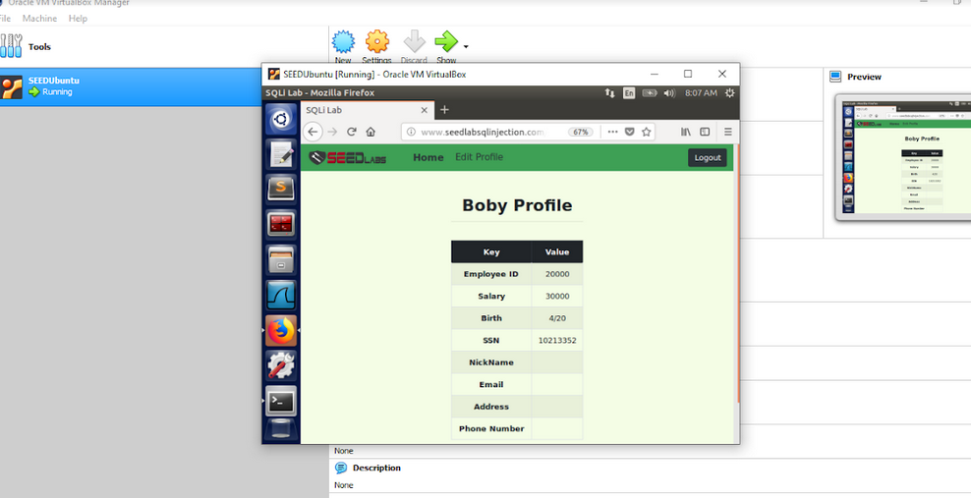

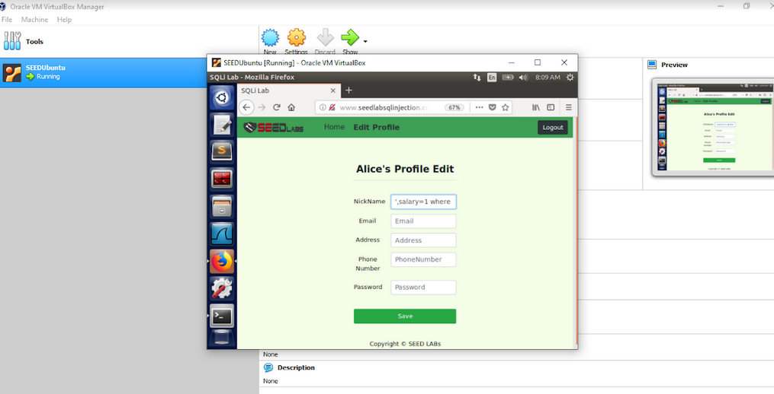

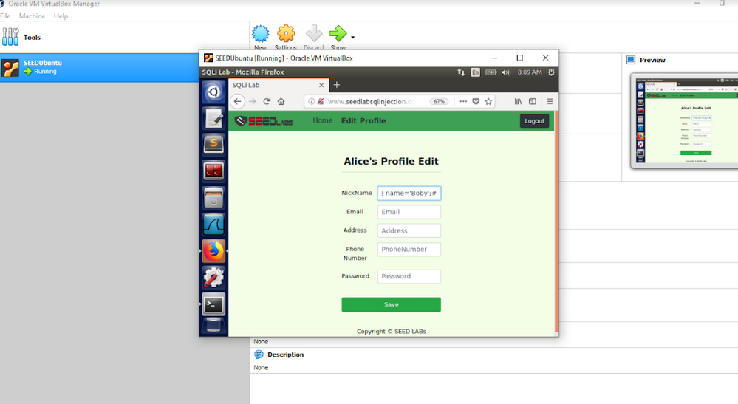

Boby Salary is modified.

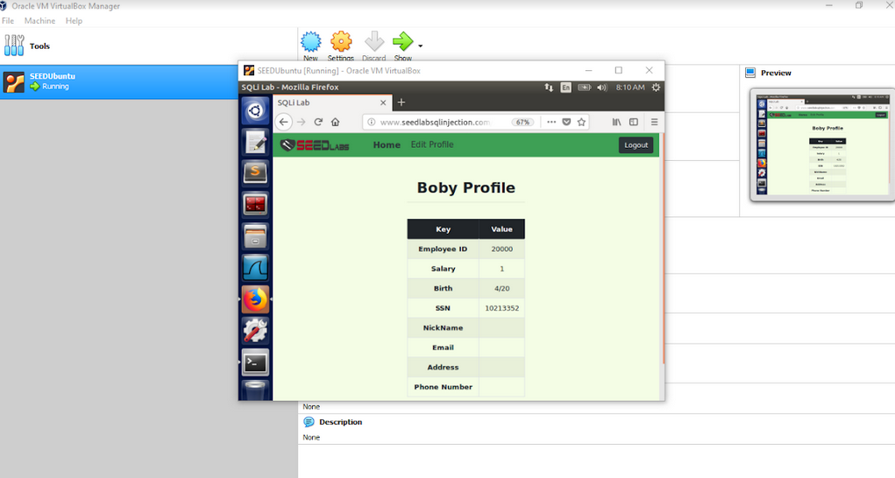

**Task 3.3: Modify other people’s passwords.**

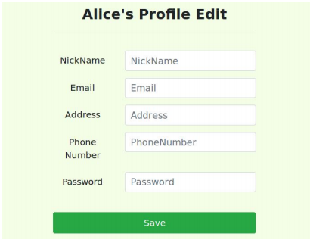

Use this command to get the original password

**echo -n “tedwashere” | shalsum**

copy the password and login to Alice's account and then modify the password.

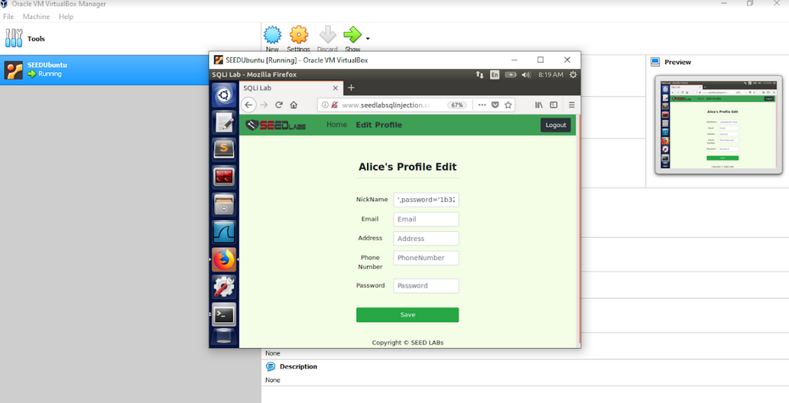

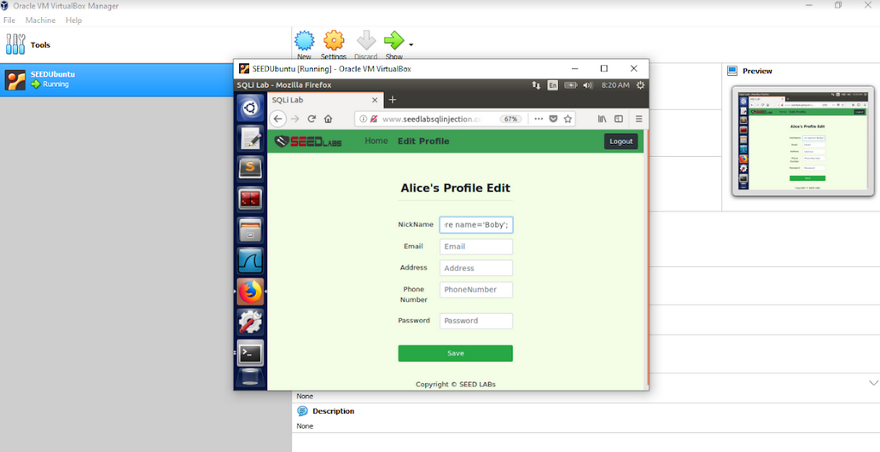

See the password is modified from this to that.

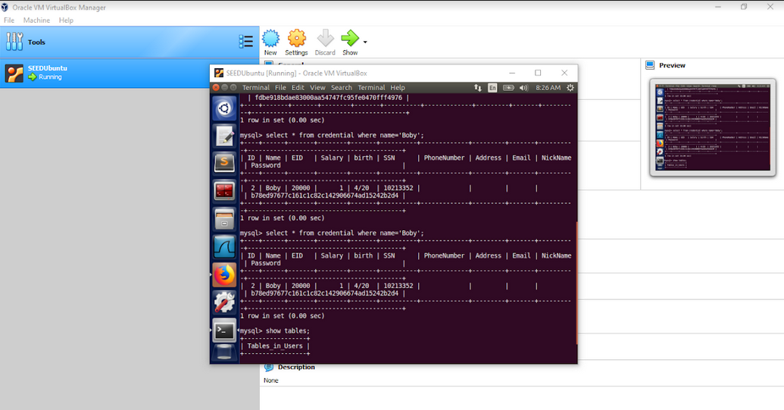

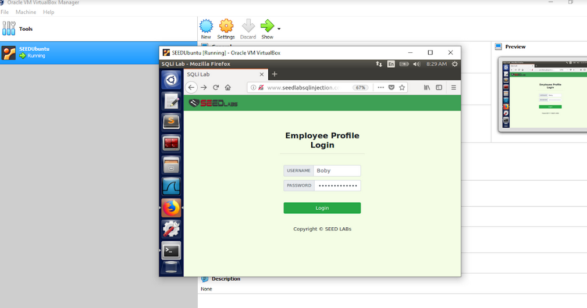

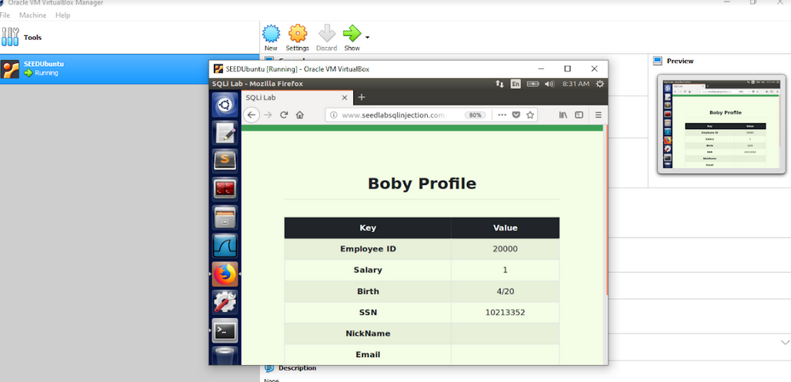

**Task 4: Countermeasure — Prepared Statement:**

So, we need to **quit** the **MySQL** and then type the commands below

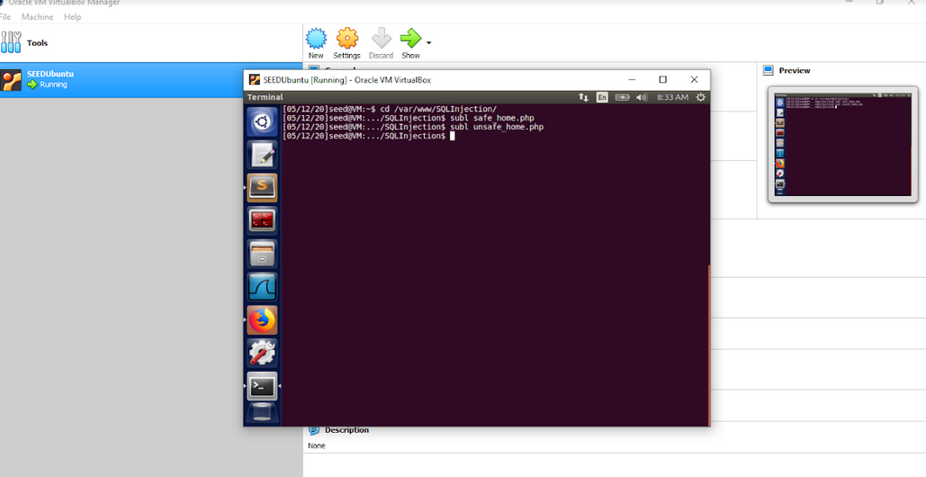

Use sublime to open the safe_home.php and unsafe_home.php files.

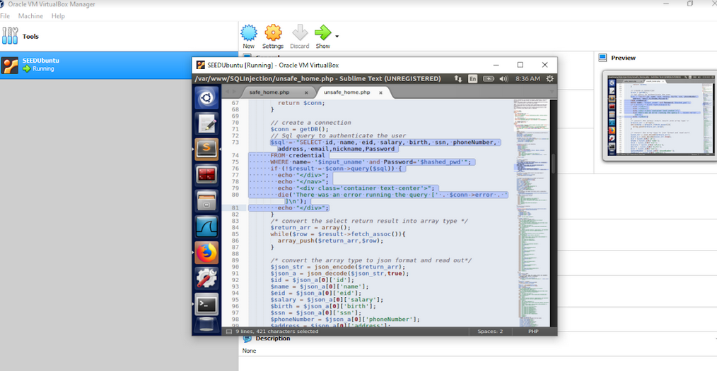

Now we need to copy the connection code from the safe_home.php.

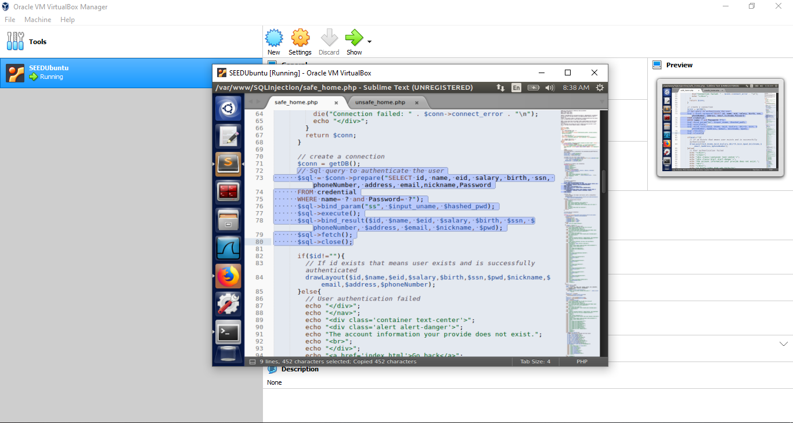

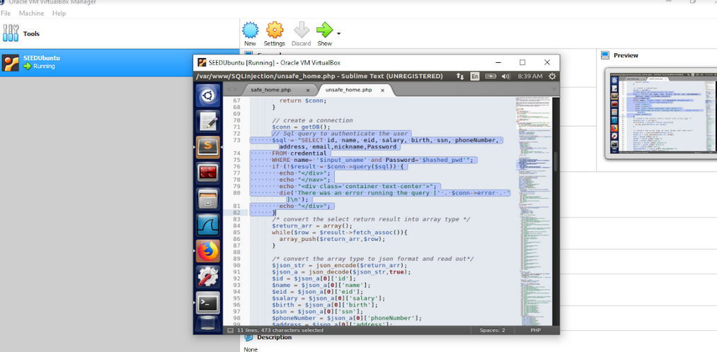

Paste it into the unsafe_home.php file.

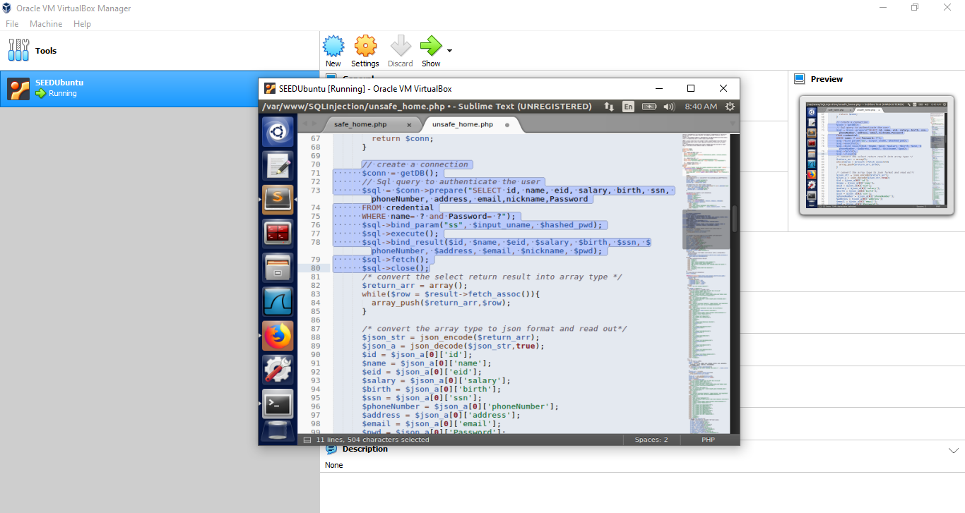

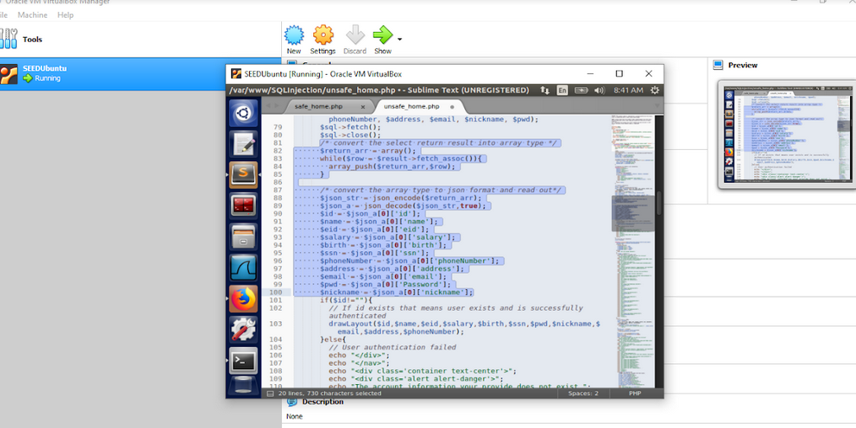

Also, remove all the unnecessary code.

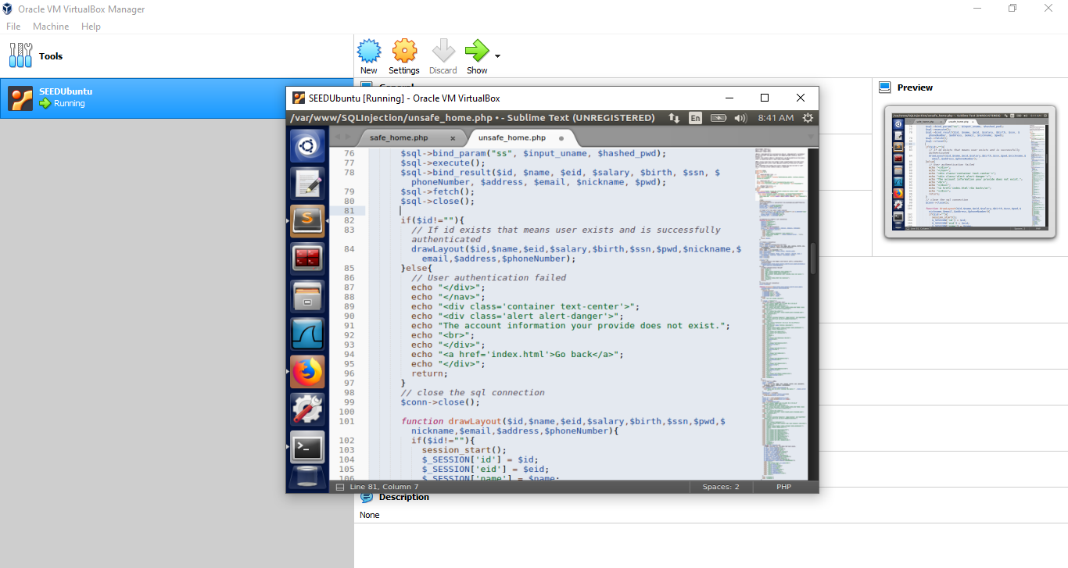

Save both files.

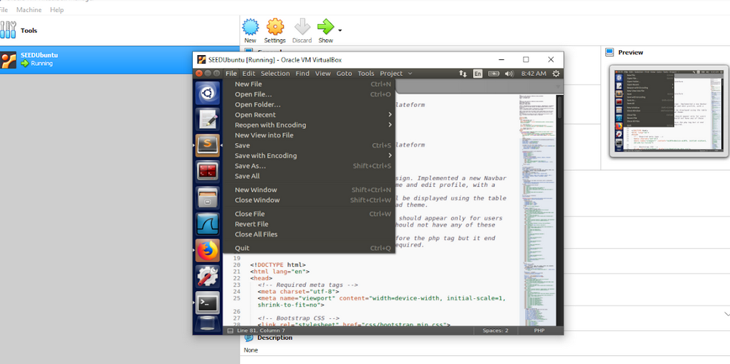

While on saving it will ask for the password. As we run the SeedUbuntu we are using a primary account which is:

• User ID: seed

• Password: dees

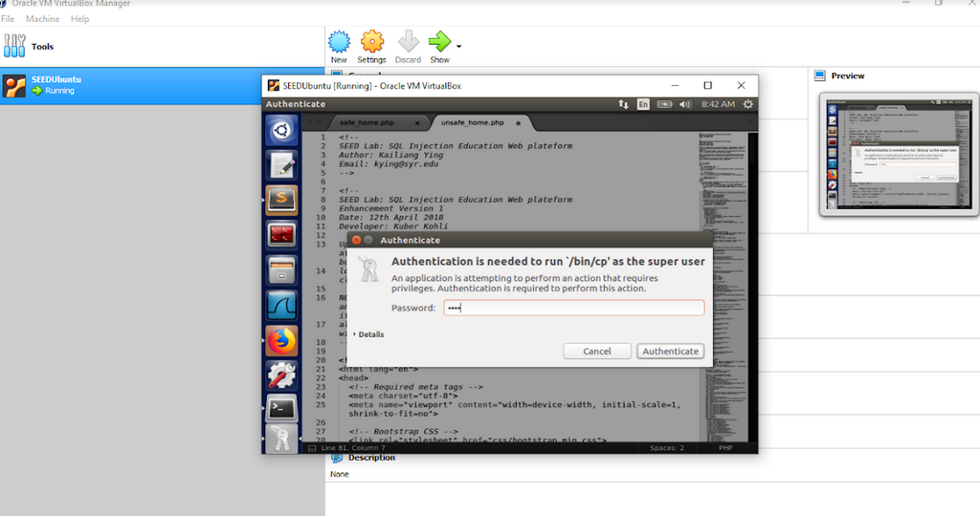

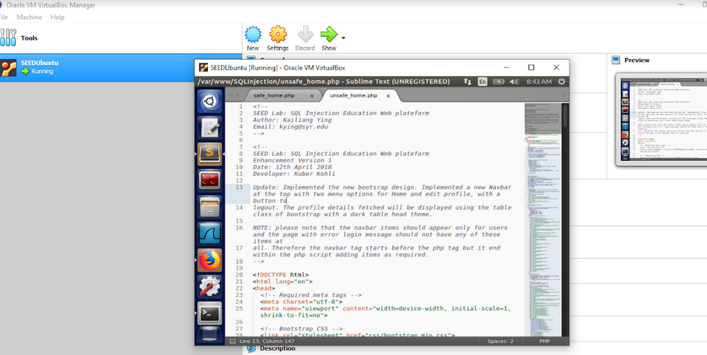

Close both files.

Now we need to reboot the PHP servers.

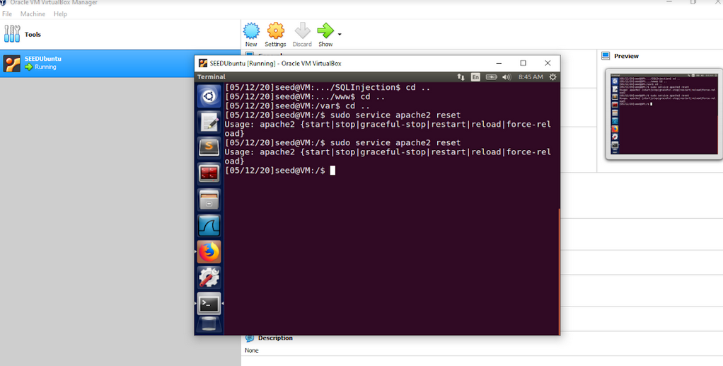

Within this field, we are going to try SQL Injection.

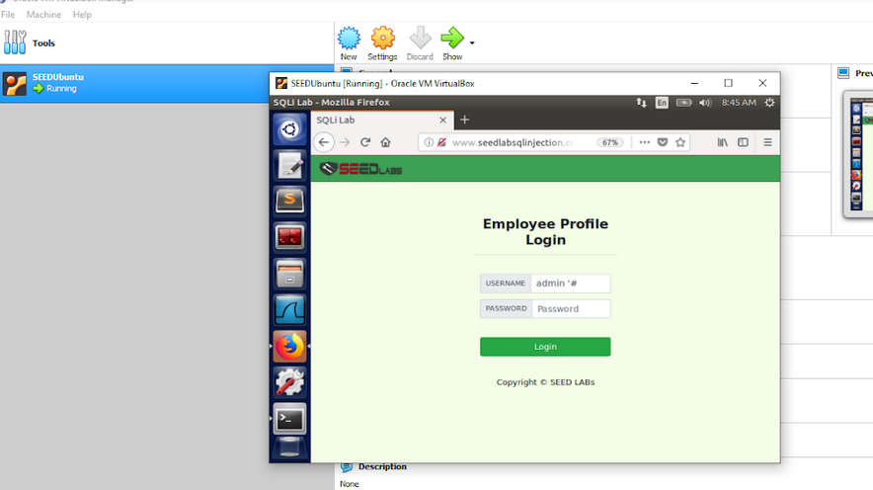

We are blocked now but it is good because we are not able to exploit the select statement which we did earlier through SQL Injection. In other words, we are successful in passing in task4.

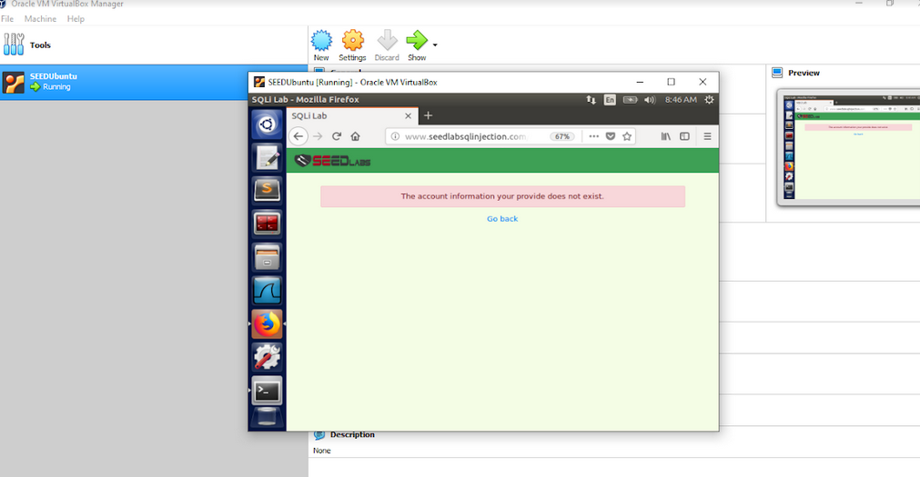

After all the work is done. We need to shut down the seed ubuntu.

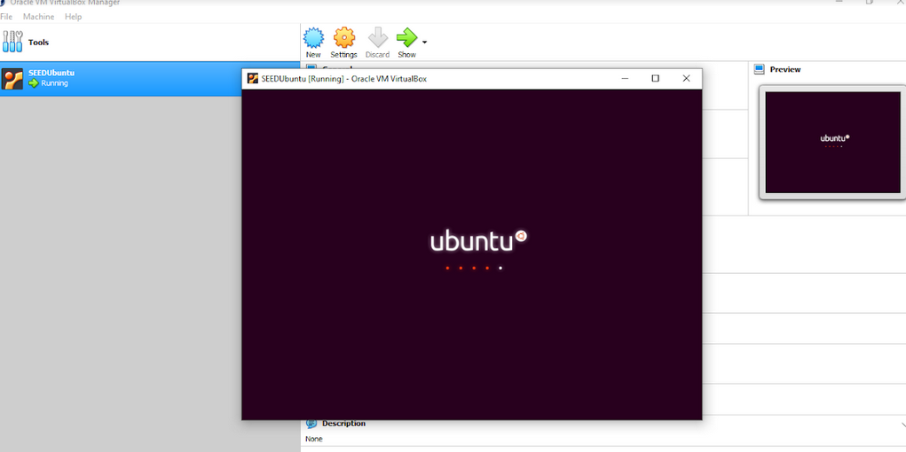

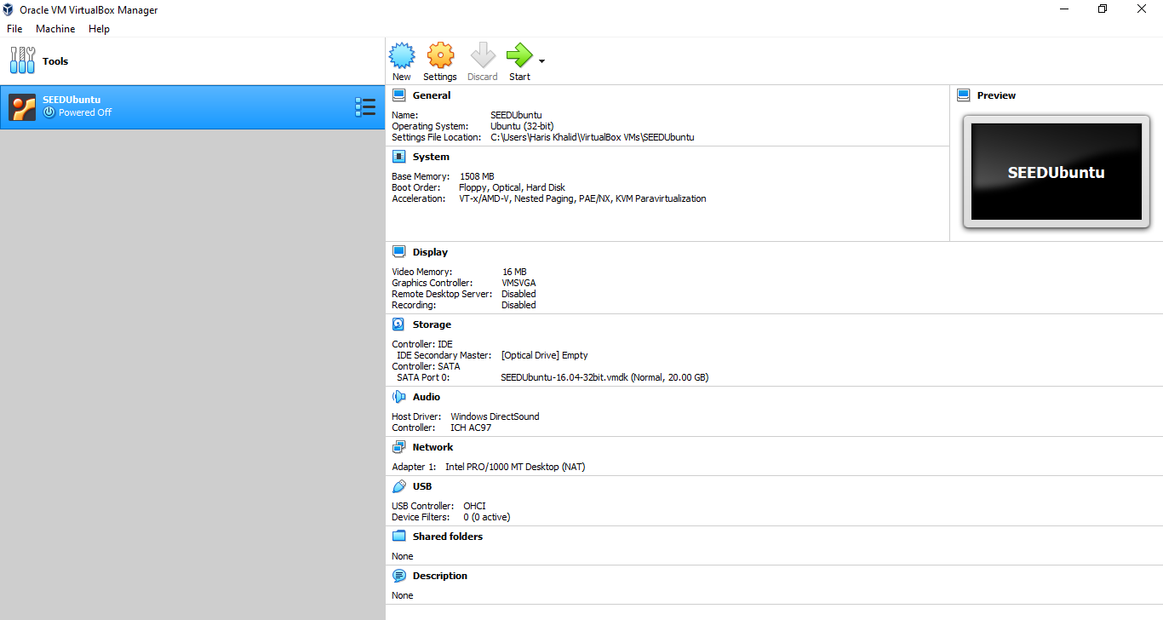

**------------------------------------------------------------------------------------------------**

**-------------------------- COMPLETED --------------------------**

**------------------------------------------------------------------------------------------------**